DOCUMENTATION

Graphical Programming Interface

Contents

Software Overview: 3

Installation Process: 3

User Interface Overview: 4

User Manual: 5

# Software Overview:

This project aims to develop a graphical programming application. Just like Microsoft Paint, the program is developed with features like making lines and shapes.

The program will be able to draw shapes with the provided graphical user interface and with command line codes as well. The program has the functionality to save the written codes in hard drive, as well as load saved text files which include the appropriate codes to draw shapes and lines.

# Installation Process:

1. Install Visual Studio Code 2019 Community Edition
2. Run Visual Studio Code 2019.
3. Choose “Open a project or solution”.
4. Choose the extracted project zip folder and select the “DrawWithCommandline.sln” file inside the folder.
5. Press “Start” on the menu bar.

# User Interface Overview:

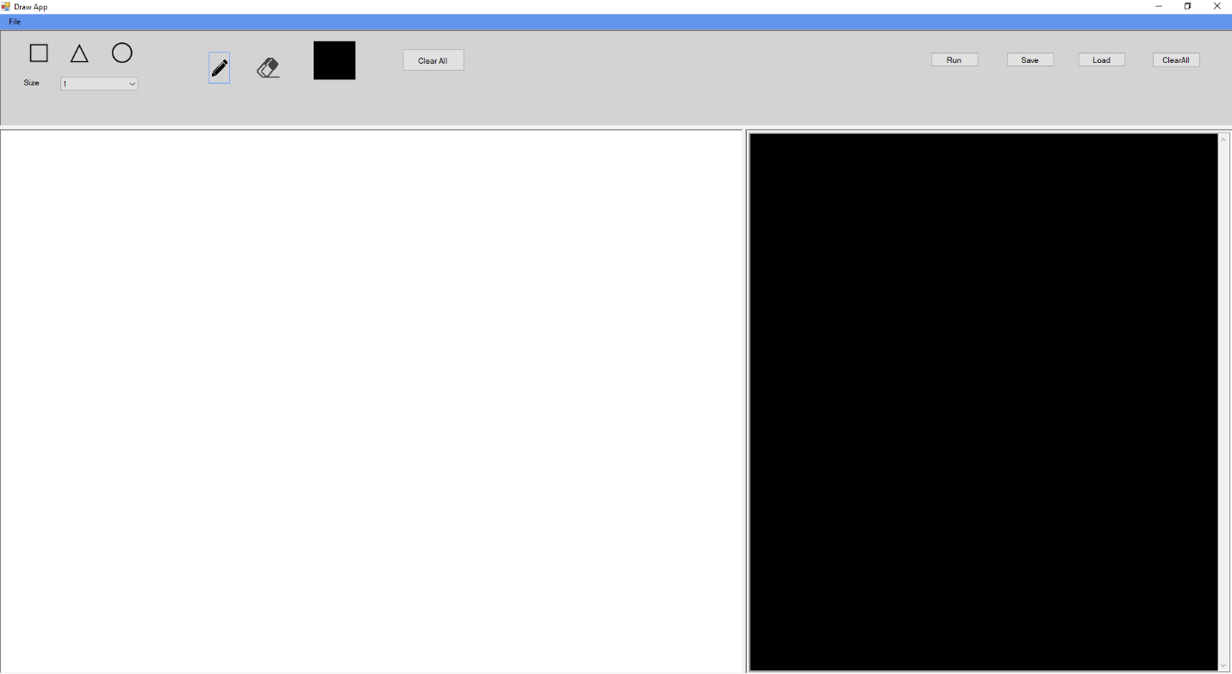

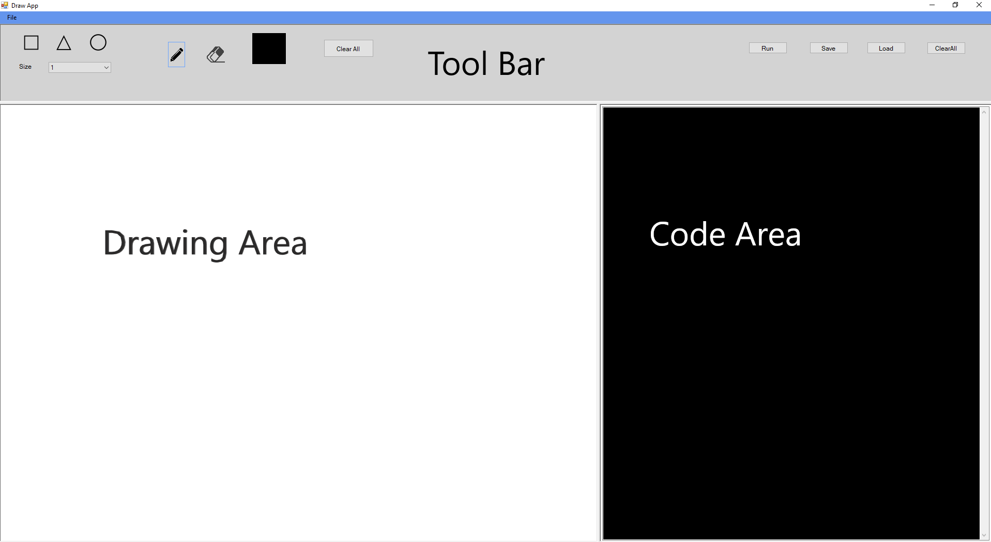

The user interface is simple and it’s easy to use the software. On the top is the menu bar. Below the menu bar, there is the tool bar. The tool bar is used to draw lines and shapes.  
The window is divided into two sections. The white area is the drawing area whereas the black area is for writing codes to draw shapes and lines.

# User Manual:

1. **Drawing basic shapes:**

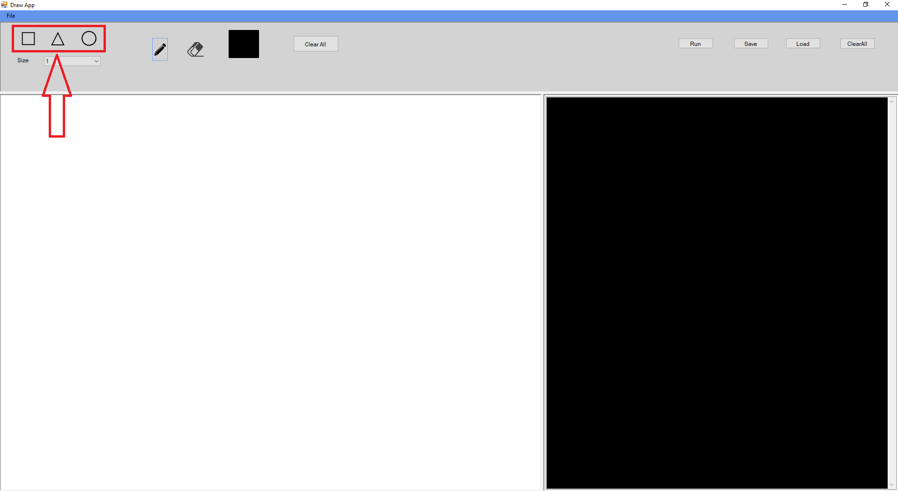

Click on any of the three provided shapes on the tools bar at the top.

Left click on the white area to draw the shape.

1. **Drawing Lines**

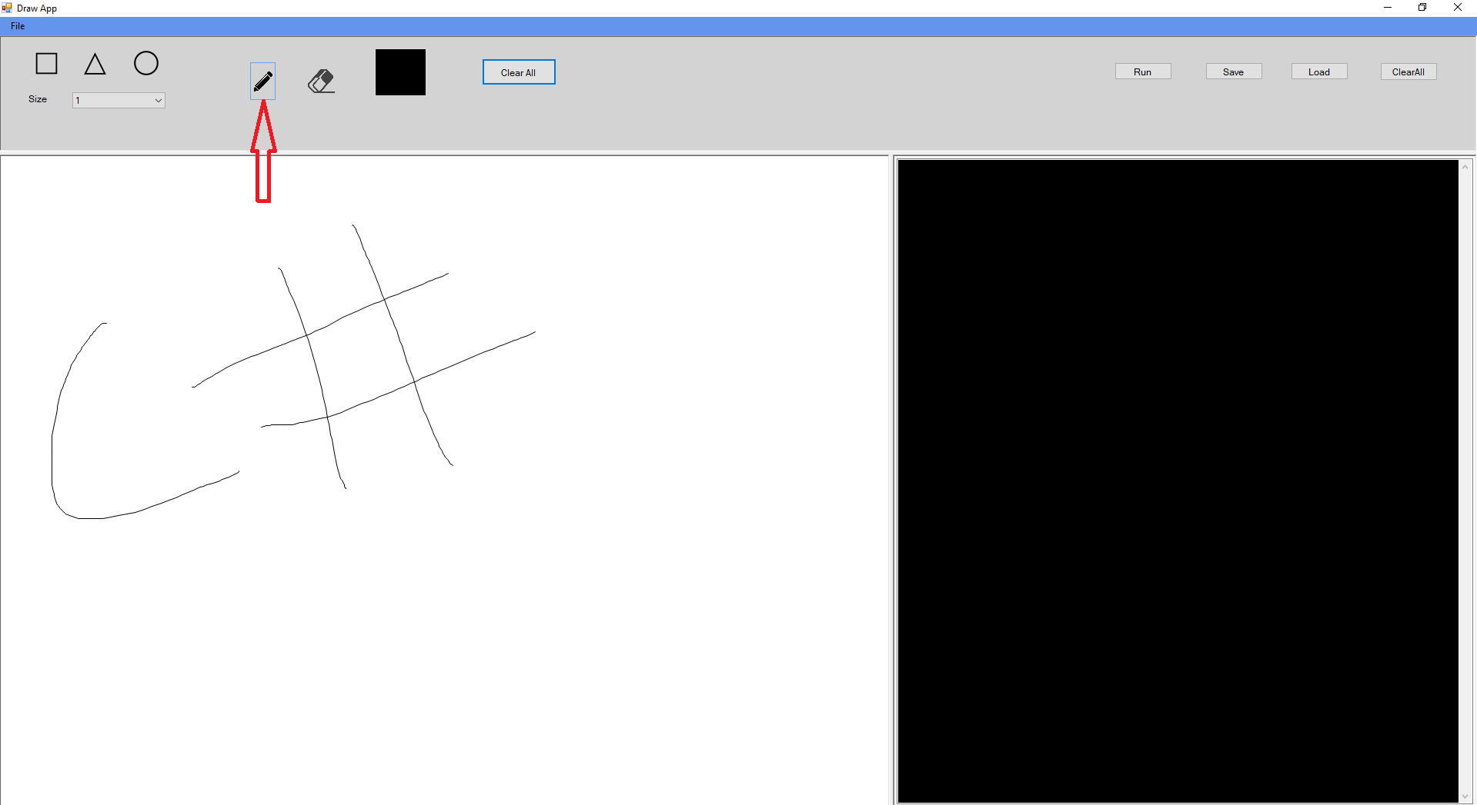

Click on the Pencil icon on the tool bar at the top.

Place your cursor on the white area.

Left click and hold, and drag the mouse to draw a line.

1. **Changing size of the shapes:**

Click on the “Size” number field on the tool bar.

Select your desired size.

Left click on the white are to draw the line or shape.

1. **Erasing the lines and shapes:**

Click on the Eraser icon on the tool bar.

Left click over the desired area to erase the lines and shapes.

1. **Clearing the lines and shapes:**

Left click on the “Clear All” button above the white area at the tool bar to clear all lines and images.

1. **Draw with command line codes:**

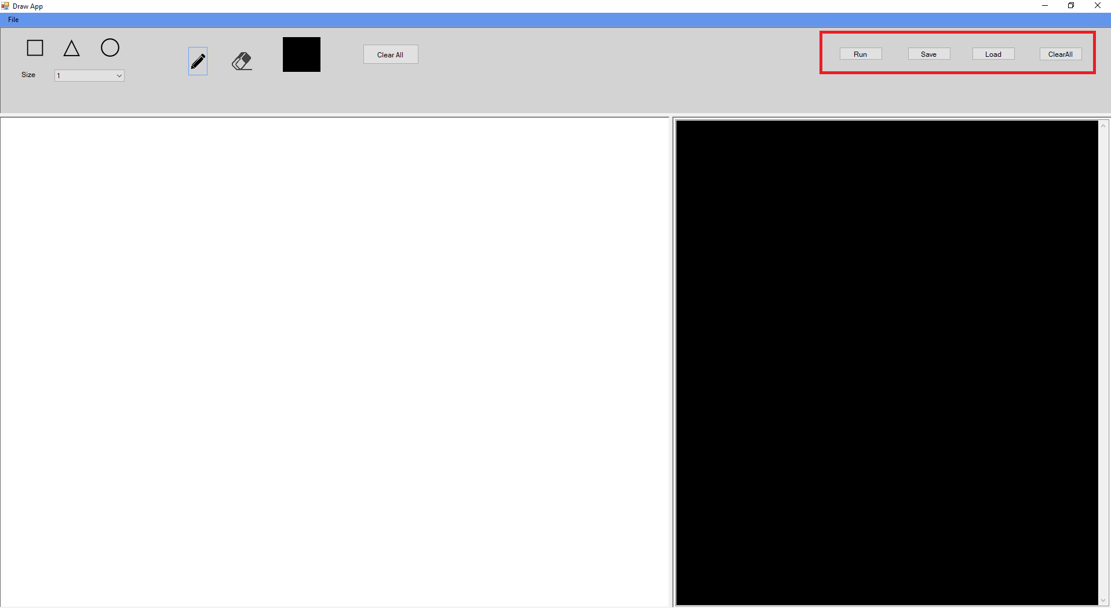

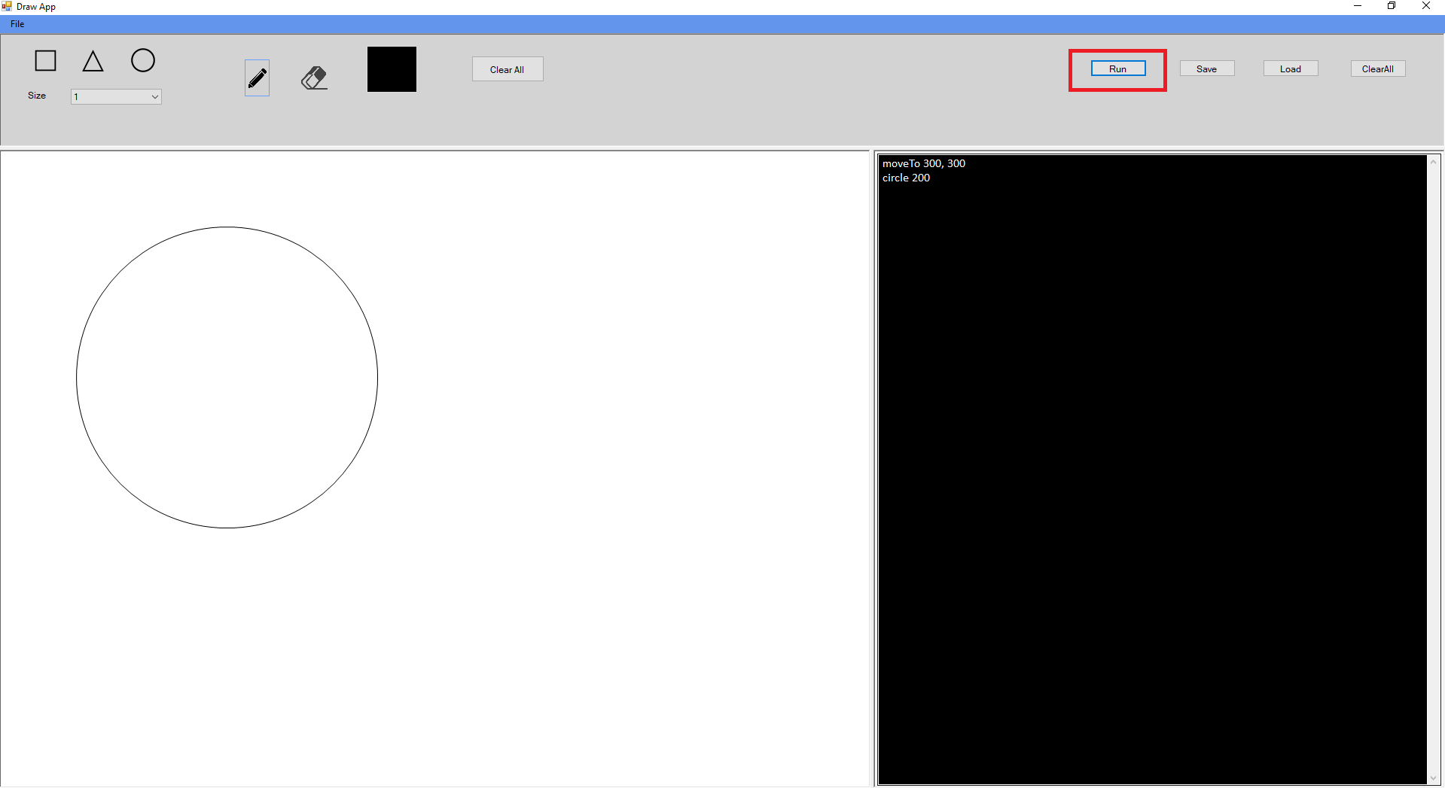

Click on the black area.

Write code for desired shape.

Click on “Run”

1. **Save written codes:**

Click on “Save” button.

Choose the folder where you want to save the file.

Rename the file to your desired name.

Click on “Save”.

1. **Load written codes:**

Click on “Load” button.

Navigate to your code’s location and left click the text file.

Click on “Open”

1. **Clear written codes:**

Left click on the “Clear All” button above the black area at the tool bar to clear all lines and images.